### *“*Email Spam Classification by using Streamlit”

**Minor Project Report Submitted To**



**Chhattisgarh Swami Vivekanand Technical University**

**Bhilai, India**

*For*

Completion of 7th Semester Minor Project of degree

*Of*

**BACHELOR OF TECHNOLOGY (HONORS)**

*In*

**Data Science**

**(COMPUTER SCIENCE & ENGINEERING)**

*By*

**Dolly Sahu**

1. **Tech (Hons) 7th Semester**

**Roll.no.- 300012821034**

**Enroll.no.- CB4685**

Under the Guidance

*Of*

**Dr. Rohit Miri**

Associate Professor

Computer Science and Engineering

CSVTU, Bhilai (CG)

### DEPARTMENT OF COMPUTER SCIENCE & ENGINEERING

### UNIVERSITY TEACHING DEPARTMENT

**CHHATTISGARH SWAMI VIVEKANAND TECHNICAL UNIVERSITY, BHILAI**

**Session:-2024**-**2025**

**DEPARTMENT OF COMPUTER SCIENCE & ENGINEERING**

**UNIVERSITY TEACHING DEPARTMENT**

**CHHATTISGARH SWAMI VIVEKANAND TECHNICAL UNIVERSITY, BHILAI**

**DECLARATION BY THE CANDIDATE**

I, the under signed solemnly declare that the Minor project report entitled **“**EMAIL SPAM CLASSIFICATION BY USING STREAMLIT**”** is based on my work carried out during the 7th semester course of my graduation under the supervision of Dr. **Rohit Miri,** Associate Professor, Computer Science and Engineering, University Teaching Department, Chhattisgarh Swami Vivekanand Technical University, Bhilai (C.G.), India.

**DOLLY SAHU**

**Roll No. 300012821034**

**Enrollment No. CB4685**

**Semester 7th (CSE)**

** DEPARTMENT OF COMPUTER SCIENCE & ENGINEERING**

**UNIVERSITY TEACHING DEPARTMENT**

**CHHATTISGARH SWAMI VIVEKANAND TECHNICAL UNIVERSITY, BHILAI**

**CERTIFICATE BY THE SUPERVISOR**

This is to certify that the incorporation in the project "**EMAIL SPAM CLASSIFICATION**" documents the Minor Project work carried out by Dolly Sahu, with Roll No. 300012821034 and Enrollment No. CB4685, under the guidance and supervision required for the completion of the 7th semester Bachelor of Technology (Honors) In Data Science (Computer Science & Engineering) at Chhattisgarh Swami Vivekanand Technical University, Bhilai (C.G.), India.

To the best of my knowledge and belief the report

1. Embodies the work of the candidate himself
2. Has duly been completed
3. Fulfills the partial requirement of the ordinance relating to the B.Tech.(Hons) degree of the University
4. Is up to the desired standard both in respect of contents and language for being referred to the examiners.

__________________________

(Signature of the Supervisor)

**DR. ROHIT MIRI**

Associate Professor, Dept of C.S.E.

UTD, CSVTU, Bhilai (C.G.)

**Forwarded to**

**Chhattisgarh Swami Vivekanand Technical University Bhilai (C.G.)**

|  |  |
| --- | --- |
| _______________________________  (Signature of HOD)  **DR. TORAN VERMA**  Associate Professor, Dept of C.S.E.  UTD, CSVTU, Bhilai (C.G.) | _______________________________  (Signature of the Director)  **DR. P K GHOSH**  Director  UTD, CSVTU, Bhilai (C.G.) |

**DEPARTMENT OF COMPUTER SCIENCE & ENGINEERING**

**UNIVERSITY TEACHING DEPARTMENT**

**CHHATTISGARH SWAMI VIVEKANAND TECHNICAL UNIVERSITY, BHILAI**

**CERTIFICATE BY THE EXAMINER**

This is to certify that the project entitled "Email Spam Classification" was submitted by **Dolly Sahu**, a student to B.Tech.(Honors)in Data Science (CSE), with Roll. No.300012821034 and Enrollment No. CB4685. It has been examined by the under signed as a part of the examination and is here by recommended for the completion of the 7th-semester Minor project for the degree of Bachelor of Technology (Honors) in Data Science (Computer Science and Engineering) at Chhattisgarh Swami Vivekanand Technical University, Bhilai (C.G.), India.

Internal Examiner External Examiner

Date: Date:

**DEPARTMENT OF COMPUTER SCIENCE & ENGINEERING**

**UNIVERSITY TEACHING DEPARTMENT**

**CHHATTISGARH SWAMI VIVEKANAND TECHNICAL UNIVERSITY, BHILAI**

**ACKNOWLEDGEMENT**

The true spirit of achieving any goal lies in the pursuit of excellence and unwavering discipline.

I express my heartfelt gratitude to **Dr. Rohit Miri**, Assistant Professor in the Department of Computer Science and Engineering, for his invaluable guidance and mentorship throughout my minor project, Email Spam Classification. His expertise, encouragement, and support were instrumental in the successful completion of this work.

I am also deeply appreciative of all the faculty members in the Department of Computer Science and Engineering for their unwavering support and the resources they provided, which were crucial to the completion of this project.

My sincere thanks go to **Dr. P. K. Ghosh,** Director of UTD, for the inspiration and continuous encouragement that motivated me to present this work with confidence and dedication.

Lastly, I am profoundly grateful to my parents and family, who have always been my greatest source of strength and inspiration. Their unwavering support, love, and encouragement have empowered me to reach this milestone. Above all, I am thankful to the almighty for bestowing upon me the confidence, resilience, and strength needed to complete this project.

**Dolly Sahu**

**Roll No. 300012821034**

**Enrollment No. CB4685**

**ABSTRACT**

The **Email Spam Classification** system is a machine learning-based project developed to classify emails as "Spam" or "Not Spam" with high accuracy and efficiency. This project leverages **Logistic Regression**, a widely used binary classification algorithm, to identify spam emails based on textual content. The model achieves an impressive accuracy of **94.32%**, ensuring reliable performance in detecting spam while minimizing false positives and negatives. The solution focuses on practicality and scalability, making it suitable for real-world applications where spam detection is crucial. The system preprocesses raw email text using the **TF-IDF Vectorizer** (Term Frequency-Inverse Document Frequency), a feature extraction technique that transforms unstructured textual data into meaningful numerical representations. This preprocessing step is essential for identifying patterns and extracting key features from the email content, enabling the Logistic Regression model to effectively distinguish between spam and non-spam emails. By focusing on meaningful word patterns and their importance, the TF-IDF Vectorizer ensures that the model learns robust features while discarding irrelevant noise in the data. **Logistic Regression** was chosen as the classification model due to its computational efficiency, interpretability, and effectiveness in binary classification tasks. The algorithm predicts the probability of an email belonging to the "Spam" or "Not Spam" category by applying the sigmoid function to the weighted sum of input features. Its coefficients provide insights into the most influential words or features contributing to the classification, offering interpretability and transparency. Additionally, Logistic Regression is well-suited for imbalanced datasets, as it can be fine-tuned to optimize metrics such as precision and recall, which are critical for minimizing errors in spam detection. To make the system user-friendly, it is deployed as a web-based application using **Streamlit**, a Python framework for creating interactive data-driven applications. The app allows users to input raw email text and receive real-time predictions, making it easy to test the model’s performance and understand its predictions. The intuitive interface and quick response times ensure a seamless user experience. This project integrates several modern technologies to build a robust and efficient spam detection system. **Scikit-learn** is used for model development and evaluation, while **Pandas** and **Numpy** handle data preprocessing and numerical computations. These tools, combined with the TF-IDF Vectorizer, streamline the workflow and ensure high-quality feature extraction and model training. The streamlined deployment through Streamlit enhances accessibility, enabling non-technical users to interact with the system effortlessly. The **Email Spam Classification** system represents the practical implementation of theoretical machine learning concepts in solving a real-world problem. By combining efficient modelling, feature extraction, and an interactive user interface, the project highlights the potential of machine learning in addressing challenges such as spam detection. Developed as part of the **7th semester minor project**, this work reflects the integration of academic knowledge with hands-on application, showcasing the ability to design and deploy a functional solution. This project not only provides a learning opportunity but also demonstrates the practical utility of machine learning in enhancing communication systems by filtering unwanted or harmful emails effectively.

#### Table of Contents

|  |  |  |
| --- | --- | --- |
| **S No.** | **Title** | **Page No.** |
|  | Introduction | 01-03 |
|  | System Analysis | 04-07 |
| 2.1 | Identification of Need | 05 |
| 2.2 | Preliminary Investigation | 06 |
|  | Feasibility Study | 08-11 |
| 3.1 | Technical Feasibility | 09 |
| 3.2 | Operational Feasibility | 10 |
|  | Analysis | 12-18 |
|  | Software Engineering Paradigm Applied | 19-21 |
|  | System Design | 22-24 |
|  | Coding | 25-27 |
|  | Implementation and Result | 28-31 |
|  | Testing | 32-34 |
|  | System Security Measure | 35-37 |
|  | Pert Chart/Gantt Chart | 38-40 |
|  | Future Scope of The Project | 41-43 |
|  | References | 44 |

#### List of Figures

|  |  |  |
| --- | --- | --- |
| **Figure** | **Title of Figure** | **Page No.** |
| Figure 4 | Data Flow Diagram Level 0 | 13 |
| Figure 4.1 | Data Flow Diagram Level 1 | 14 |
| Figure 4.2 | Data Flow Diagram Level 2 | 15 |
| Figure 4.3 | Entity Relationship Diagram | 17 |
| Figure 8.1 | App View Main Page | 30 |
| Figure 8.2 | Dataset Visualization | 31 |
| Figure 8.3 | Model Prediction | 31 |

#### List of Abbreviations

1. **HTML** - Hypertext Markup Language
2. **RGB** - Red, Green & Blue
3. **PNG** - Portable Network Graphics
4. **CSS -** Cascading Style Sheet

**CHAPTER– I**

**INTRODUCTION**

**CHAPTER–I**

**INTRODUCTION**

* 1. **Background Information**

Emails are an essential part of modern communication, serving as a primary medium for professional and personal correspondence. However, the pervasive issue of spam emails poses significant challenges, ranging from productivity loss to potential security threats. Spam emails, which include unsolicited advertisements, phishing attempts, and malicious links, disrupt workflows and compromise data security. To address this problem, machine learning-based spam classification systems have emerged as effective solutions, capable of distinguishing between legitimate and spam emails with high accuracy.

* 1. **Project Objectives**

The primary objectives of the **Email Spam Classification** project are:

* To develop a machine learning model capable of accurately classifying emails as "Spam" or "Not Spam."
* To achieve a classification accuracy of over 90% while minimizing false positives and false negatives.
* To deploy the model as a user-friendly web-based application for real-time email spam detection.
* To integrate advanced feature extraction techniques and modern frameworks to ensure scalability and practical usability.
  1. **Significance of the Project**

This project addresses a critical need for automated and efficient spam detection in the digital age. Traditional rule-based spam filters struggle to adapt to the dynamic nature of spam, where content evolves to bypass predefined rules. By leveraging machine learning, the system adapts to changing spam patterns, ensuring robustness and reliability. Furthermore, this project highlights the practical application of theoretical concepts in machine learning, demonstrating how academic knowledge can be transformed into impactful solutions. The deployment of this system as a web-based application enhances its accessibility and usability, providing a tangible benefit to users across various domains.

* 1. **Scope and Limitations**

**Scope:**

* The project focuses on using **Logistic Regression** as the core classification algorithm, optimized for binary classification tasks.
* The system preprocesses email text using the **TF-IDF Vectorizer**, ensuring high-quality feature extraction from raw data.
* A user-friendly interface is developed using **Streamlit**, enabling users to input email text and receive predictions in real-time.
* The model achieves a classification accuracy of **94.32%**, demonstrating its reliability in detecting spam.

**Limitations:**

* The system’s performance may depend on the quality and representativeness of the training data.
* It primarily handles English-language emails, as preprocessing techniques are tailored to this language.
* The model may require periodic retraining to adapt to emerging spam patterns and evolving email content.
* Computational efficiency and response times may vary depending on the deployment environment.
  1. **Overview of the Structure**

This document is structured as follows:

* **Section 2**: Methodology, detailing the data preprocessing, feature extraction, and model development process.
* **Section 3**: System Design, describing the architecture and integration of the machine learning model with the web-based interface.
* **Section 4**: Results and Discussion, presenting the model’s performance metrics and analysis.
* **Section 5**: Conclusion and Future Work, summarizing the achievements and potential enhancements for the project.

By addressing the challenges of spam detection through a machine learning-based solution, this project showcases the potential of technology to improve digital communication and user experience

**CHAPTER – II**

**SYSTEM ANALYSIS**

**CHAPTER –II**

**SYSTEM ANALYSIS**

**2.1 Identification of Need**

The need for an Email Spam Classification system arises from the increasing volume of unsolicited and harmful emails that users receive daily. Spam emails pose a significant threat to productivity, security, and the overall user experience in communication systems. Traditional filtering methods often fail to provide the desired accuracy, leading to either over blocking (blocking legitimate emails) or under blocking (missing actual spam). Therefore, there is a pressing need for a robust and efficient system capable of accurately distinguishing spam from non-spam emails.

Key drivers for this system include:

* **Improved Communication Efficiency:** By filtering spam effectively, users can focus on legitimate emails without distractions.
* **Time-Wasting and Distractions**: Spam emails clutter users' inboxes, making it harder to sift through legitimate communication. Users spend a considerable amount of time manually sorting emails, which decreases their productivity. By efficiently filtering out spam, the system allows users to focus on important messages, enhancing workflow and communication efficiency.
* **Prioritization of Emails**: With an effective spam filtering system, legitimate emails can be prioritized, ensuring that users don't miss critical messages or communications that require timely responses.
* **Enhanced Security:** Spam emails often carry malicious content, such as phishing links or malware. A reliable classification system reduces the risk of cyber threats.
* **Malware and Phishing Threats**: A large portion of spam emails carry malicious attachments or phishing links aimed at compromising user security. These emails often contain malware, ransomware, or links to fraudulent websites designed to steal sensitive personal information, such as login credentials or financial details.
* **Cybersecurity Protection**: An automated spam classification system can play a vital role in defending against cyber threats. By accurately identifying and blocking potentially harmful emails, the system reduces the likelihood of a successful attack, thus contributing to the overall cybersecurity posture of individuals and organization
* **Scalability and Automation:** Manual filtering of emails is impractical. The system provides an automated, scalable solution suitable for various environments.
* **Manual Efforts are Impractical**: As the volume of email communication increases, manually identifying and filtering spam becomes unfeasible. Relying on users to identify spam would require significant time and attention, leading to inefficiency.
* **Automated and Scalable Solution**: The system automates the spam detection process, enabling it to handle large volumes of emails efficiently. This scalability makes the system suitable for both individual users and organizations of all sizes. Whether a small business or a large enterprise, the system can scale to meet the demands of diverse environments.
* **Continuous Adaptation**: The system can evolve by incorporating new spam trends and emerging threats, adapting to changes in spam tactics, ensuring that it remains relevant and effective over time.
* **User Experience:** Ensuring that legitimate emails are not misclassified as spam improves trust and usability.
* **Accuracy in Classification**: One of the key challenges with traditional spam filters is balancing false positives (legitimate emails being classified as spam) and false negatives (spam emails being allowed through). Poor filtering leads to frustration, with users either missing critical emails or being burdened with spam.
* **Reliability and Trust**: By implementing a machine learning-based classification system, the accuracy of spam detection can be significantly improved, reducing the chances of legitimate emails being misclassified. This results in a more reliable and user-friendly experience.
* The system addresses these needs through the application of advanced machine learning techniques, offering high accuracy and reliability in spam detection.

**2.2 Preliminary Investigation**

The preliminary investigation involved:

* **Understanding the Problem:** Analyzing the challenges of spam email detection and studying existing solutions.
* **Challenges**: Spam emails can vary in content, format, and sophistication. They may contain obfuscated content to evade simple filters, and they often change tactics over time. Identifying spam with a high degree of accuracy is challenging due to the evolving nature of spam strategies.
* **Existing Solutions**: We reviewed current email spam filtering techniques, which generally fall into two categories:
* **Rule-based filters**: These use predefined rules to identify spam based on keywords or patterns. However, these often result in high false-positive rates or are easily bypassed by spammers using new tactics.
* **Machine learning-based filters**: These use algorithms to learn from labeled data and improve over time. Machine learning models are more adaptive and accurate in detecting new spam patterns but require high-quality data and continuous retraining.
* **Data Collection:** Gathering a dataset of emails labeled as "Spam" or "Not Spam" to train and evaluate the machine learning model.

Data collection is crucial for training and evaluating the spam classification model:

* **Dataset of Labeled Emails**: We sourced datasets containing both **spam** and **non-spam** (ham) emails. Common datasets used for training spam filters include the **Enron Spam Dataset**, **SMS Spam Collection**, and **Spam Assassin**. These datasets are labeled, which makes them suitable for supervised learning.
* **Data Quality**: Ensuring that the dataset is representative of real-world email communication is essential for training an effective model. The dataset should cover various email formats, topics, and possible spam strategies to ensure robustness.
* **Technology Review:** Evaluating various algorithms and tools, such as Logistic Regression, TF-IDF Vectorizer, and Streamlit, for their suitability in building the system.
* **TF-IDF Vectorizer**: This technique was selected for feature extraction. TF-IDF helps in converting the email text into a numerical format that reflects the importance of each word in the email. This representation is ideal for feeding into machine learning models.
* **Logistic Regression**: After evaluating multiple classification algorithms, Logistic Regression was chosen due to its simplicity, efficiency, and interpretability. Logistic regression is a probabilistic model that works well for binary classification problems like spam detection, where emails need to be classified as either "Spam" or "Not Spam."
* **Streamlit**: For the deployment of the model, Streamlit was chosen because it provides an easy-to-use interface for building and sharing machine learning applications. Its integration with Python, especially with machine learning libraries like Scikit-learn, makes it a practical choice for deploying this system in a real-time web application.
* **Feasibility Assessment:** Ensuring the project aligns with technical, operational, and economic constraints.
* **Technical Feasibility**: The technologies chosen (Python, Scikit-learn, TF-IDF, and Streamlit) are widely adopted and well-documented, ensuring a smooth development process. The system is expected to run on standard hardware, and the use of machine learning algorithms allows for scalability.
* **Operational Feasibility**: The system is designed to be intuitive and easy to use, which is important for real-world deployment. Users can simply upload emails, and the system will return a classification, making it user-friendly.
* **Economic Feasibility**: The system can be built using open-source tools, significantly lowering development and deployment costs. As the solution is scalable, it can be applied in both small businesses and large enterprises without requiring significant resources

**CHAPTER – III**

**FEASIBILITY STUDY**

**CHAPTER– III**

**FEASIBILITY STUDY**

**3.1 Technical Feasibility**

The Email Spam Classification system is technically feasible as it leverages widely adopted tools and technologies such as Python, Scikit-learn, Pandas, Numpy, and Streamlit. The preprocessing is handled by TF-IDF Vectorizer, ensuring compatibility with existing datasets and efficient feature extraction. Logistic Regression is computationally efficient and interpretable, making it a suitable choice for binary classification. The web application is deployed using Streamlit, ensuring minimal resource requirements and ease of deployment.

**Email Spam Classification System** is **technically feasible** due to the integration of proven technologies and methodologies that ensure both accuracy and efficiency in the classification task. Here’s a breakdown of the core technical elements that make the system feasible:

**a. Technologies Used:**

1. **Python**: Python is a widely-used programming language for machine learning and data analysis. Its rich ecosystem of libraries and tools (such as **Scikit-learn**, **Pandas**, and **Numpy**) makes it an ideal choice for this project. Python’s simplicity, flexibility, and vast community support make it a great fit for rapid development and iterative improvements.
2. **Scikit-learn**: This library provides a variety of tools for **machine learning**, including pre-built functions for model training, evaluation, and prediction. The logistic regression model, used in this system, is part of Scikit-learn, making it easy to train and deploy for spam classification. Scikit-learn is computationally efficient, offering both speed and scalability for the email classification task.
3. **Pandas and Numpy**: These libraries are essential for **data manipulation** and **numerical computations**. **Pandas** is used for preprocessing email data, such as cleaning and transforming the raw email text into structured data, while **Numpy** supports efficient handling of numerical data during the training of the machine learning model.
4. **Streamlit**: Streamlit allows for the quick creation of interactive web applications. With minimal effort, it enables the deployment of the email spam classification system, providing an easy-to-use interface where users can upload email data and get real-time spam predictions. Streamlit applications are lightweight and require minimal resources for hosting, making it ideal for rapid prototyping and deployment.

**b. Preprocessing with TF-IDF:**

1. **TF-IDF (Term Frequency-Inverse Document Frequency)** is a popular text feature extraction technique that helps convert raw email text into numerical data that a machine learning model can process. This ensures that each word in the email is represented in a way that reflects its importance in relation to the entire corpus of emails.
2. The **TF-IDF Vectorizer** works by assigning weights to words based on their frequency in a document and how unique they are across the dataset. This technique handles variations in language and can differentiate between common words (like "the" or "is") and words that are specific to spam emails (such as "free" or "offer"), which is crucial for effective spam detection.

**c. Logistic Regression:**

1. **Logistic Regression** is a simple yet powerful model for binary classification tasks like spam detection. It is computationally efficient, meaning that it can handle large volumes of email data without requiring significant processing power. Additionally, logistic regression is interpretable, which means that the model’s decisions can be understood and traced back to the specific features of the emails. This transparency is crucial for debugging the system and for users who want to understand why an email was classified as spam or not.
2. The logistic regression model is trained on labeled data (emails that have been manually categorized as spam or not spam). After training, the model can predict the likelihood that a given email is spam based on its features (such as word frequencies extracted via TF-IDF).

**d. Deployment with Streamlit:**

1. **Streamlit** simplifies the deployment process, allowing for a **web-based interface** where users can interact with the email spam classification system. This is beneficial because it provides **easy accessibility** from any modern web browser, removing the need for users to install software or manage complex infrastructure.
2. Streamlit is highly compatible with Python and integrates smoothly with machine learning models built using libraries like **Scikit-learn**. The deployment process is straightforward, and the system can be accessed by end-users in real-time without complicated setup steps.

**3.2 Operational Feasibility**

The system is operationally feasible as it provides an intuitive web-based interface for users to classify emails as "Spam" or "Not Spam." It requires minimal technical knowledge to operate, making it user-friendly. The deployment ensures scalability and accessibility, suitable for real-world environments where spam detection is critical.

The operational feasibility of the **Email Spam Classification System** refers to its ability to perform well in real-world conditions, ensuring it meets user needs while being easy to use and scalable. Here’s why the system is operationally feasible:

**a. User-Friendly Web Interface:**

The system uses **Streamlit** to provide an intuitive, easy-to-navigate web interface. Users can simply upload raw email text or email files, and the system will process the data and classify it as "Spam" or "Not Spam."

* **Minimal User Knowledge Required**: Users do not need any technical expertise to interact with the system. The interface is designed to be as simple as possible, requiring users to just upload emails and receive results instantly. This is crucial for organizations or individuals who may not be familiar with machine learning or data science but still require accurate spam detection.
* **Real-Time Spam Classification**: The system classifies emails in real time, offering immediate feedback to the user. This is important in environments like **corporate settings** where spam emails need to be identified quickly to avoid security threats or productivity loss.

**b. Scalability and Accessibility:**

The system is designed to be **scalable**, meaning that it can handle a growing volume of emails as more users interact with it. Since **Streamlit** applications are web-based, the system can be easily scaled up by deploying it on cloud servers (e.g., AWS, Google Cloud, or Azure) with minimal configuration.

* **Cloud Deployment**: The system can be deployed to the cloud, ensuring that the application is accessible from any location without dependency on local infrastructure. This makes it particularly useful for organizations with remote teams or for end-users across different geographical regions.
* **Integration Capabilities**: The system can be extended and integrated into existing email servers or enterprise systems (such as Outlook or Gmail), making it applicable in real-world operational environments. Integration with email clients would allow the system to automatically filter incoming emails and classify them, preventing spam before it reaches the user's inbox.

**c. Real-World Use Case Suitability:**

* **Spam Detection** is a critical aspect of email communication in many sectors (e.g., **corporate environments**, **financial institutions**, **healthcare**, and **personal email**). The system’s operational feasibility extends beyond small-scale use and can be adapted for large-scale environments where spam filtering is essential for maintaining security and productivity.
* **Automation of Manual Processes**: In many organizations, spam detection is still done manually or through basic keyword-based filters. This system automates the process, saving time and reducing the risk of human error. It can also be continuously trained and improved as new spam trends emerge, ensuring that the classification remains accurate.
* **Feedback Mechanism**: The system can incorporate a feedback loop from users, allowing for the refinement of the model over time. Users could flag false positives or negatives, and the system could be retrained with these new data points to improve accuracy, making the system dynamic and responsive to changing spam tactics.

**d. Minimal System Requirements:**

The system’s web interface is lightweight, ensuring that it does not require high-end hardware or significant resources for operation. Users can access it on low- to mid-end devices (e.g., laptops, tablets) with modern web browsers. This broadens the operational scope and ensures that the system can be deployed in environments with limited technical resources.

**CHAPTER – IV**

**ANALYSIS**

**CHAPTER– IV**

**ANALYSIS**

**Data Flow Diagram (DFD)**

The **Data Flow Diagram (DFD)** illustrates how data moves through the system, providing an overview of

the system’s functionality at different levels.

#### ****Level 0 (High-Level Overview)****

* **Input:**
  + Raw email text is provided by the user via the **Streamlit web interface**.
* **Process:**
  + The system **preprocesses** the raw email (e.g., removes HTML tags, tokenizes the text, removes stopwords).
  + The processed email is then passed to the **classification model** (e.g., **Logistic Regression**) to predict whether the email is spam or not.
* **Output:**
  + The system outputs a **Spam** or **Not Spam** label.

##### Level 0 Diagram (Conceptual Overview):

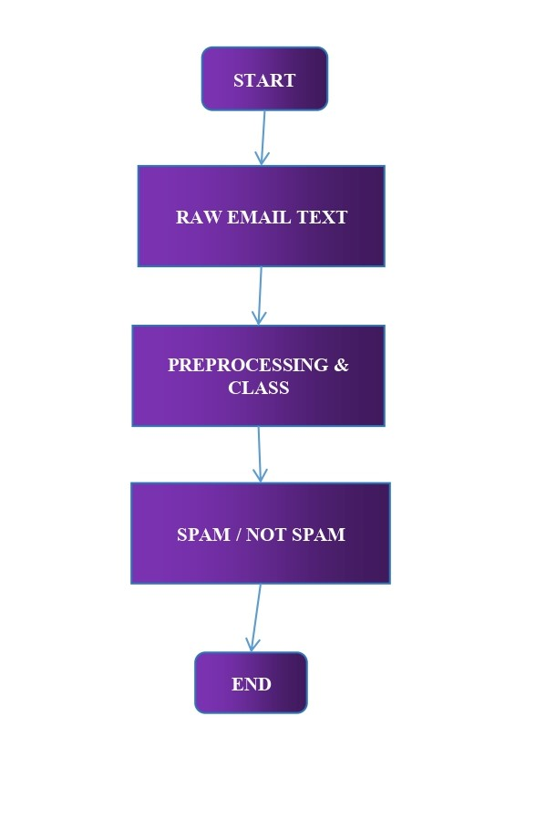

#### ****FIGURE 4:- DFD LEVEL 0****

#### ****Level 1 (Detailed Overview)****

* **Input:**
  + The system receives the **email content** (e.g., raw email body).
* **Process:**
  + **Tokenization**: Breaks the email into smaller text units (tokens like words or phrases).
  + **TF-IDF Vectorization**: Converts the tokens into numerical vectors based on their frequency and importance across all emails.
  + **Logistic Regression Classification**: Uses the **TF-IDF features** as input to the Logistic Regression model to classify the email.
* **Output:**
  + The system outputs a **probability score** (indicating the likelihood of the email being spam) and the **final classification label** (spam or not spam).

##### Level 1 Diagram (Detailed Process):

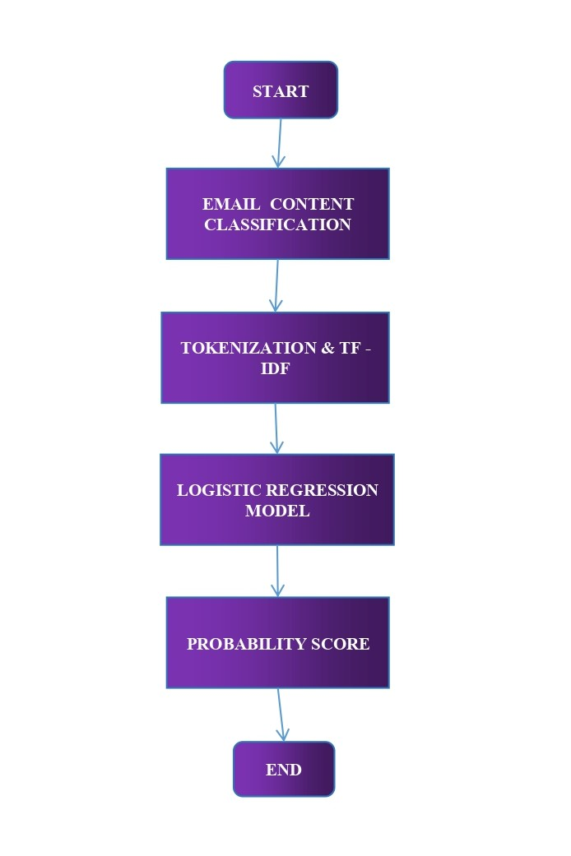

#### ****FIGURE 4.1:- DFD LEVEL 1****

#### ****Level 2 (Detailed Feature Extraction and Classification Process)****

* **Input:**
  + The **processed email tokens** are input into the **TF-IDF vectorizer**.
* **Process:**
  + **TF-IDF Matrix Creation**: The system creates a **sparse matrix** to represent the importance of each word (or token) in the email, relative to the entire dataset.
  + **Logistic Regression Model**: The **TF-IDF matrix** is passed to the logistic regression model for classification, using the trained model coefficients.
* **Output:**
  + The final classification is either **Spam** or **Not Spam**, with a confidence level score that represents the certainty of the classification.

##### Level 2 Diagram (Feature Extraction and Classification Detail):

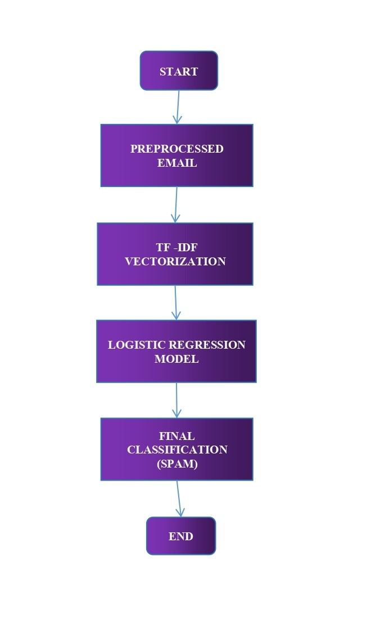

### ****FIGURE 4.2: DFD LEVEL 2****

### ****3. Entity-Relationship (ER) Diagram****

The **Entity-Relationship (ER) Diagram** provides a detailed view of the relationships between the different entities involved in the email spam classification system. It highlights how raw input data, processed data, and results are related.

#### ****Entities in the ER Diagram:****

1. **Email:**

* Attributes:
* email_id, raw_text, processed_text
* The **Email** entity stores the raw and processed text of the email, including its unique identifier.

1. **Preprocessing:**

* Attributes: preprocess_id, cleaned_text
* The **Preprocessing** entity holds the cleaned version of the email text, obtained after tokenization, stopword removal, etc.

1. **TF-IDF Features:**

* Attributes: feature_id, tfidf_vector
* The **TF-IDF Features** entity stores the vectorized form of the email, where each token is represented numerically.

1. **Classification:**

* Attributes: classification_id, classification_label, confidence_score
* The **Classification** entity holds the result of the email classification (Spam/Not Spam), along with a confidence score.

#### ****Relationships:****

* **Email → Preprocessing**: An email goes through preprocessing to remove unnecessary parts and prepare it for feature extraction.
* **Preprocessing → TF-IDF Features**: Preprocessed text is passed to the **TF-IDF feature extraction** to generate numerical representations of the text.
* **TF-IDF Features → Classification**: The **TF-IDF features** are used as input for the **Logistic Regression** classification model to generate the final result.

##### ER Diagram (Conceptual Overview):

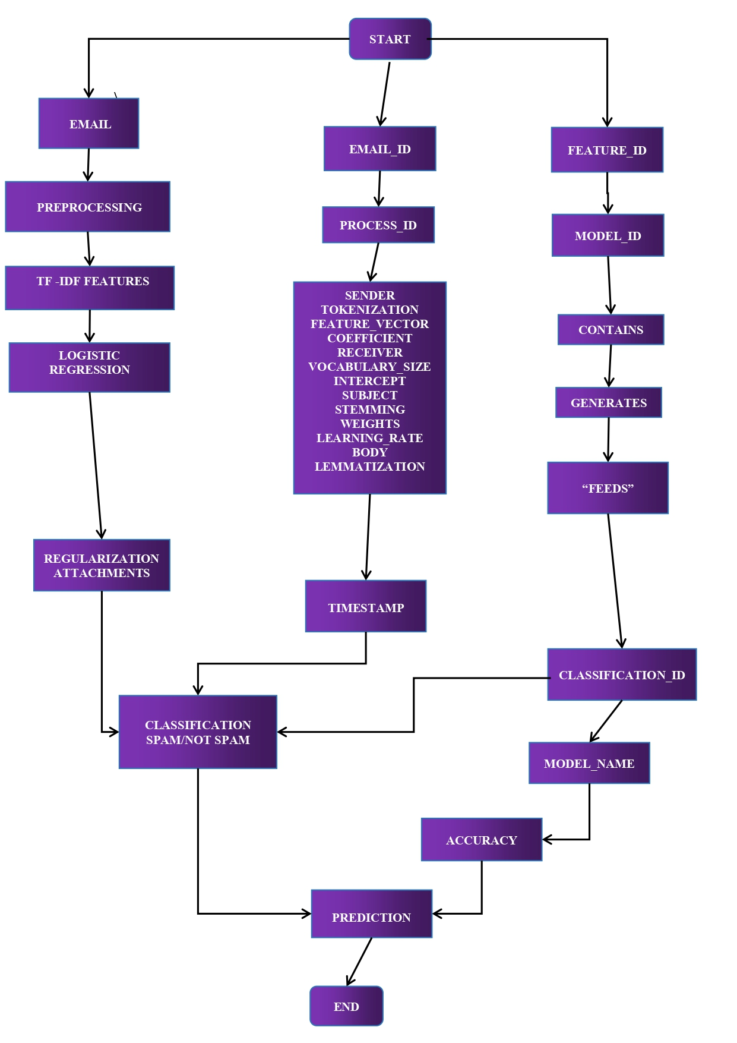

### ****FIGURE 4.3:- ER DIAGRAM****

### ****4. Data Structures****

* **TF-IDF Matrix (Sparse Matrix):**
  + A **sparse matrix** is used to store the **TF-IDF values** of each term (word) across different emails. This matrix represents how important each word is in each email relative to the entire dataset.
  + Example:

| * **Term/Email** | * **Email 1** | * **Email 2** | * **Email 3** |
| --- | --- | --- | --- |
| * "free" | * 0.3 | * 0.5 | * 0.1 |
| * "money" | * 0.4 | * 0.1 | * 0.2 |
| * "offer" | * 0.1 | * 0.2 | * 0.7 |

* **Logistic Regression Model:**
  + This is a **coefficient matrix** (weights) that helps in predicting whether an email is spam or not. The matrix also includes the **bias term**.

**CHAPTER – V**

**SOFTWARE ENGINEERING PARADIGM APPLIED**

**CHAPTER–V**

**SOFTWARE ENGINEERING PARADIGM APPLIED**

**Software Engineering Paradigm Applied**

The Iterative Development Model is applied, allowing incremental development and testing of the email spam classification system. This ensures flexibility in refining preprocessing steps, model accuracy, and user interface design.

Software & Hardware Requirement Specification:

**Software Requirements**

* Python 3.8 or higher
* The system is built using Python, which is a widely-used programming language for machine learning and data processing. Python 3.8 or higher is recommended because it ensures compatibility with libraries and supports modern Python features.
* Libraries: Scikit-learn, Pandas, Numpy, Streamlit
* Scikit-learn: A popular machine learning library that provides a wide range of tools for classification, regression, and clustering tasks. It is used for training the machine learning models (e.g., Logistic Regression).
* Pandas: A powerful data manipulation and analysis library that helps in preprocessing and cleaning the email data.
* Numpy: A library for numerical computing, useful for handling arrays, matrices, and mathematical operations in the classification model.
* Streamlit: A Python framework used for creating web applications quickly. Streamlit is used to build the interactive web interface where users can upload emails and view classification results.
* IDE: Jupyter Notebook, VS Code
* Jupyter Notebook: Ideal for developing, testing, and visualizing code in an interactive manner, particularly for data science and machine learning tasks.
* VS Code (Visual Studio Code): A versatile code editor that supports Python and a variety of extensions to help with code writing, debugging, and testing.
* Web Browser
* The system's web interface is accessed via a web browser. A modern browser (e.g., Google Chrome, Mozilla Firefox) is necessary for users to interact with the system via the Streamlit interface.

**Hardware Requirements**

* Minimum 4 GB RAM
* A minimum of 4 GB RAM is required to handle the data processing and machine learning tasks. Since email data can vary in size, additional memory ensures that multiple emails can be processed simultaneously without significant lag or errors.
* More memory (e.g., 8 GB or 16 GB) is recommended for larger datasets or when working with more complex models.
* Processor: Dual-core or higher
* A dual-core processor or higher (e.g., Intel i5, i7, or equivalent) is necessary for handling the tasks of feature extraction, classification, and running the Streamlit web server.
* Multi-core processors improve the performance of data processing and model training by allowing parallel computations.
* Storage: 10 GB free space

A minimum of **10 GB of free storage** is required to store the following:

* The **email dataset** for training and testing the model.
* The **trained model** files.
* The necessary Python libraries and dependencies.
* Web application files for hosting the **Streamlit interface**.

**CHAPTER – VI**

**SYSTEM DESIGN**

**CHAPTER–VI**

**SYSTEM DESIGN**

**System Design**

**The system design includes a modular architecture with preprocessing, feature extraction, and classification modules. The web interface is integrated with the backend for real-time predictions.**

**Include screenshots of:**

1. The web interface.

* **Purpose:** Provides an interactive and easy-to-use interface for users to upload emails and view classification results.
* **Features:**
* **Email Upload:** Users can upload email content in various formats (e.g., .txt, .eml).
* **Result Display:** After classification, the result ("Spam" or "Not Spam") is displayed along with the original email content.
* **Real-time Predictions:** Provides instant feedback on whether the uploaded email is classified as spam or not.

1. **Input and output examples.**

This section provides examples of the email content before and after the classification process.

* **Input Example:** A typical email that the system will classify.
  + **Raw Email:**
  + Subject: You’ve Won a $1000 Gift Card!
  + Congratulations! You have been selected for a special offer. Click here to claim your gift: [Suspicious Link]
  + Best regards,
  + Spam Team
* **Preprocessed Email (After Cleaning and Tokenization):**
  + congratulations selected special offer click claim gift suspicious link spam team
* **Output Example:** After the email is processed, the model will classify it as either **Spam** or **Not Spam**.
  + **Classification Result:** Spam
  + **Confidence Score (optional):** 95%

##### Example of Input and Output:

**Description:** The raw email is shown on the left, and the classification result ("Spam") is displayed on the right.

1. **Preprocessing steps.**

Preprocessing is a crucial part of the system, as it prepares the raw email data for feature extraction. Below are the steps involved in the preprocessing module.

**Raw Email (Before Cleaning):**

<html>

<body>

<p>Dear Customer,</p>

<p>Congratulations! You have won a $1000 gift card. Please click <ahref="http://spam-link.com">here</a> to claim your prize.</p>

<footer>Best Regards,<br>Spam Company</footer>

</body>

</html>

**Cleaned Email (After Preprocessing):**

congratulations won gift card click claim prize spam link

**Steps:**

* **Remove HTML Tags:** All <html>, <body>, <footer>, etc., are removed.
* **Remove Special Characters:** Links and other special characters (e.g., http://spam-link.com) are excluded.
* **Tokenization:** The text is split into individual tokens (words).
* **Stopword Removal:** Common words like "you", "the", and "to" are removed as they do not help in classifying the email.
* **Lemmatization:** Words are reduced to their root form (e.g., "winning" becomes "win").

##### Example of Preprocessing Steps:

**Description:** The raw email content is cleaned, tokenized, and reduced to its core components, ready for feature extraction.

**CHAPTER – VII**

**CODING**

**CHAPTER–VII**

**CODING**

**Coding**

**The implementation uses Python, with the core components:**

**1. TF-IDF Feature Extraction**

Text data needs to be converted into a numerical format for machine learning models to process. **TF-IDF** (Term Frequency-Inverse Document Frequency) is a statistical technique used to evaluate how important a word is in a document relative to the entire corpus. It helps in identifying words that are unique or characteristic of specific emails, making it highly suitable for spam detection.

* Logistic Regression training and prediction.
* Once we have transformed the email content into numerical features using TF-IDF, we can train a machine learning model. For this example, we will use **Logistic Regression**, which is a popular and efficient model for binary classification tasks like spam detection.
* Streamlit-based interface for deployment.
* Once the model is trained, the next step is to deploy it as a web application. **Streamlit** is an excellent tool for building interactive apps with minimal code, allowing us to quickly turn the spam classification model into a usable web interface.

TF-IDF (Term Frequency-Inverse Document Frequency) is a technique to convert text data into numerical vectors that can be processed by machine learning models. Here's how it works:

**Term Frequency (TF):** This measures how frequently a term (word) appears in a document. The more times a word appears, the higher its frequency. It can be normalized by the total number of terms in the document to account for longer documents.

**Inverse Document Frequency (IDF):** This measures how important a word is across the entire corpus. Words that are common across all documents (like "the", "is", "and") get a lower IDF score. Words that appear less frequently across the corpus but are common within specific documents (e.g., "free", "winner") get a higher IDF score.

**TF-IDF:** By multiplying these two scores (TF and IDF), we get a value that reflects how important a word is in a given document relative to the whole corpus.

**Logistic Regression Training and Prediction**

Once the email text has been transformed into numerical features using TF-IDF, we can proceed to train a machine learning model. Logistic Regression is a popular choice for binary classification tasks like spam detection. It assigns a probability score to each document, helping us predict whether an email is spam or not.

**Streamlit-based Interface for Deployment**

Streamlit is an excellent tool for creating interactive web applications with minimal effort. After the model is trained, we can deploy it with a simple web interface where users can input text (such as an email) and get predictions on whether the email is spam or not.

**Final Steps for Deployment:**

Training the Model: Train the model on a labeled dataset of emails, split into training and testing sets.

* **Save the Model and Vectorizer:** Once you have a trained model, save it using joblib to load it in the Streamlit app.
* **Streamlit Deployment:** Build a simple web app using Streamlit to accept input from users, transform it using the same TF-IDF vectorizer, and make predictions using the trained Logistic Regression model.
* **Host the Application:** You can deploy your Streamlit app to platforms like Streamlit Cloud or other cloud services.

**CHAPTER – VIII**

**IMPLEMENTATION AND MAINTAINANCE**

**CHAPTER–VIII**

**IMPLEMENTATION AND RESULT**

**Implementation and Maintenance**

The system is implemented as a Streamlit web application, ensuring portability and ease of access. Maintenance involves updating libraries, optimizing the model, and incorporating user feedback.

#### ****8.1 Setting Up the Streamlit Web Application****

**Streamlit Setup:**

Streamlit provides a simple framework to create web applications directly from Python scripts. To implement the email spam classification system, the model can be wrapped into a Streamlit app that allows users to interact with it via a graphical interface. Streamlit enables you to deploy the model without needing extensive frontend development skills.

**Steps for Streamlit Setup:**

* Install Streamlit: pip install streamlit
* Create a Python script (e.g., app.py) to build the user interface.
* Streamlit’s layout allows for creating interactive widgets, such as file upload buttons, text inputs, and buttons to trigger the classification.

**User Interface (UI):**

The interface can include:

* + **Email Upload:** Allow users to upload email files (e.g., .txt, .eml, .csv, or .json).
  + **Text Display:** Show the email’s content for review.
  + **Classification Output:** Display the classification result as either "Spam" or "Not Spam" after the model processes the input email.
  + **Model Feedback:** Provide users with an option to submit feedback, such as "Is this classification accurate?" which helps improve the system.

#### ****Email Preprocessing and Feature Extraction****

* **Preprocessing Module:**  
  The first step in classifying emails involves cleaning and preprocessing the email text. This includes:
* Removing unnecessary characters like HTML tags, signatures, and other non-essential elements.
* Tokenizing the email content into words or sentences.
* Removing stop words and stemming or lemmatizing words to reduce them to their root form.
* Extracting features like the presence of suspicious words, sender's domain, frequency of certain terms, and metadata like the email's subject and time of sending.
* **Feature Extraction:**  
  After preprocessing, the next step involves converting the text into a format that can be input into the machine learning model. This is typically done using techniques such as:
* **TF-IDF (Term Frequency-Inverse Document Frequency):** Converts text data into numerical vectors.
* **Word Embeddings (e.g., Word2Vec, GloVe):** Converts words into dense vectors based on their semantic meaning.
* **Bag of Words:** Creates a vector representation based on the frequency of words in the email content.

#### ****Machine Learning Model Integration****

* **Model Training:**  
  Once the preprocessing and feature extraction steps are complete, the spam classifier is trained using labeled email datasets (containing both spam and non-spam emails). Algorithms like **Logistic Regression**, **Random Forest**, **Naive Bayes**, or **Deep Learning** models (e.g., LSTM or CNN) can be used for classification.
* **Model Evaluation:**  
  Evaluate the model’s performance using metrics like accuracy, precision, recall, and F1-score to ensure it performs well on a test dataset.
* **Model Deployment:**  
  The trained model is integrated into the Streamlit web application. Users will interact with the app by uploading emails, which will be passed through the trained model to obtain a classification.

### ****8.2. Result****

### The images collectively showcase the features and functionality of the deployed Streamlit app. The first image highlights the clean and intuitive layout, with a prominently displayed title and a visually appealing background. The second image illustrates the app's ability to visualize dataset trends and patterns through detailed graphs. Finally, the third image demonstrates the interactive user experience, showing how inputs are processed to generate dynamic outputs, emphasizing the app's practicality and user-friendly design.

### The first image captures the overall layout of the deployed Streamlit application. The app's title is prominently displayed, accompanied by a visually appealing background image that enhances the interface's aesthetic appeal. The layout is designed to be clean and intuitive, ensuring a smooth user experience.

### 

### FIGURE 8.1: App View Mainpage

### The second image focuses on the graphical representations derived from the dataset used in the app. These graphs provide an overview of the data trends and patterns, offering users a clear and detailed visualization of the insights. The charts are seamlessly integrated, reflecting the app's analytical capabilities.

### 

### FIGURE 8.2: Dataset Visualization

### The third image highlights the app’s core functionality by showcasing the input fields and their corresponding outputs. It demonstrates how users can interact with the app, providing data or parameters and receiving dynamic results or insights in real-time. This feature emphasizes the app's user-centric and interactive design.

### 

### FIGURE 8.3: Model Prediction

**CHAPTER – IX**

**TESTING**

**CHAPTER–IX**

**TESTING**

**Testing**

**Testing Techniques**

* **Unit Testing: Validation of individual modules such as preprocessing and classification.**
* **Integration Testing: Ensuring seamless integration of modules.**
* **Unit Testing**
* **Description:** Unit testing involves testing individual modules of the email spam classification system in isolation. The purpose is to verify that each module performs as expected before it is integrated into the larger system.

**Application in Spam Classification:**

* **Preprocessing Module:** Test functions like text cleaning, tokenization, stop-word removal, and feature extraction to ensure that the input data is processed correctly.
* **Feature Extraction:** Validate that features like the frequency of specific words, email metadata (e.g., subject, sender, or timestamp), or any other extracted attributes are calculated correctly.
* **Spam Classifier:** Ensure that the spam classification model (e.g., logistic regression, decision trees, or neural networks) functions correctly when fed with input data. This includes verifying if the model correctly classifies emails based on predefined labels (spam or not).
* **Tools:** Python's unittest or pytest libraries can be used for unit testing individual functions and methods in the code.

**Integration Testing**

**Description:** Integration testing ensures that different modules of the spam classification system work together as expected when integrated. The goal is to check the interaction between components and the flow of data between them.

**Application in Spam Classification:**

* **Preprocessing + Feature Extraction + Model:** After unit testing the individual components, you can check the overall workflow to ensure the processed email data is fed correctly into the classifier and that the system outputs the correct classification (spam or not spam).
* **Error Handling:** Test the system’s ability to handle edge cases, like malformed emails or emails with missing metadata.
* **Model Integration:** Verify that the classifier is receiving features from the preprocessing and feature extraction modules correctly and that the output from the model can be properly interpreted for further processing (e.g., sending the results to the user interface or backend system).
* **Tools:** Use integration testing frameworks like Selenium (for web applications) or Postman (for APIs) to simulate how different modules interact.

**Testing Strategies**

1. **Cross-Validation**

* **Description:** Cross-validation is a technique used to assess the performance of a machine learning model. It involves splitting the dataset into multiple subsets (folds), training the model on somefolds, and testing it on the remaining folds. This helps estimate the model's ability to generalize to unseen data.

**Application in Spam Classification:**

* **K-Fold Cross-Validation:** The dataset is divided into 'k' folds (typically 5 or 10). The model is trained and tested multiple times using different combinations of the folds for training and testing. This helps ensure the classifier is not overfitting to a particular subset of data and provides a more robust performance estimate.
* **Stratified Cross-Validation:** Since the dataset may contain an imbalanced distribution of spam and non-spam emails, stratified cross-validation ensures that each fold has a similar proportion of spam and non-spam examples, maintaining balance in the training and test sets.
* **Tools:** Popular libraries like scikit-learn provide built-in functions for cross-validation, such as cross_val_score and StratifiedKFold.

1. **Stress Testing**

**Description:** Stress testing evaluates how well the email spam classification system performs under high workloads or large volumes of data. The goal is to ensure that the system can handle real-world email traffic, including thousands or even millions of incoming emails.

* **Application in Spam Classification:**
* **Handling Large Datasets:** Simulate large email volumes by feeding the system with massive email datasets. Monitor how the system’s performance scales in terms of classification time, accuracy, and resource utilization (CPU, memory).
* **Real-Time Email Processing:** Test the ability of the system to classify emails in real time. For example, test how quickly the system can classify emails as they are received, ensuring that spam emails are flagged instantly to prevent inbox overload.
* **Model Scalability:** Measure how the model performs as the dataset size increases. Test if the system remains responsive and can handle additional processing requirements without significant delays.
* **Tools:** Use performance testing tools like **JMeter** or **Locust.io** to simulate heavy traffic and evaluate the system's response time and scalability. Additionally, stress testing frameworks in cloud platforms (like AWS or Azure) can be used to simulate scaling and load scenarios.

**CHAPTER – X**

**SYSTEM SECURITY MEASURE**

**CHAPTER–X**

**SYSTEM SECURITY MEASURES**

**System Security Measures**

**Input sanitization to prevent injection attacks.**

* **Threats**: One of the major security risks that web applications face is **injection attacks**.
* These include SQL injection, command injection, and cross-site scripting (XSS) attacks, where an attacker injects malicious code into the application via user inputs (e.g., email content).
* These types of attacks can compromise the system's integrity, allow unauthorized access, or disrupt the functioning of the application.

**Solution**:

* **Sanitize Email Input**: The system will ensure that any email input or content processed by the application is sanitized before being used in any backend processes. This includes filtering out any special characters or scripts that could potentially be executed as part of an injection attack. Common malicious inputs, such as <script>, DROP TABLE, or -- (SQL comments), will be identified and neutralized before the data is passed through the model or stored in the database.
* **Validation and Escape Characters**: Any user-provided email content will be validated to ensure it conforms to the expected format (e.g., no HTML tags or SQL commands). Additionally, special characters will be properly escaped to prevent them from being interpreted as executable code.
* **Data Escaping**: All output (such as email classifications) sent back to the user interface will be properly escaped, preventing issues like XSS (cross-site scripting), where malicious JavaScript might be injected into the web page.

**HTTPS deployment for secure communication.**

* + **Threats**: Without secure communication protocols, attackers can intercept and alter the data exchanged between the client (user) and the server (backend system).
  + This could result in data breaches, where sensitive user information such as email content, classification results, or personal details could be exposed.
  + For example, in a Man-in-the-Middle (MitM) attack, an attacker could intercept email data being transmitted and alter the classification results.

**Solution**:

* **Use of HTTPS (HyperText Transfer Protocol Secure)**: The system will enforce HTTPS as the communication protocol to ensure that all data exchanged between the client and server is encrypted.
* HTTPS uses **SSL/TLS certificates** to secure the connection, preventing attackers from intercepting or tampering with the data during transmission. This is crucial when users are uploading or submitting their email content to the system for classification.
* **Certificate Management**: SSL/TLS certificates will be acquired from trusted certificate authorities (CAs), ensuring that communication is encrypted using robust cryptographic methods. The certificates will be periodically updated and maintained to ensure they meet the latest security standards.
* **HTTP Strict Transport Security (HSTS)**: To further reinforce HTTPS usage, the system will implement HSTS headers, which instruct the browser to always use HTTPS when communicating with the server, thus preventing any accidental usage of HTTP (non-secure).

**Logging mechanisms for tracking usage and debugging.**

* **Threats**: Logging is essential not only for troubleshooting and improving the system but also for maintaining security. In the absence of effective logging, attackers may exploit system vulnerabilities undetected, making it harder to trace malicious activity.
* Additionally, proper logging helps in identifying potential system misuse, such as the submission of spammy content designed to test or circumvent the system.

**Solution**:

* **Activity Logging**: The system will maintain logs of all critical events such as email submissions, user interactions, system errors, and classification results. Logs will include timestamps, user IDs (if applicable), and action types (e.g., classification of an email as spam or not spam). This will help in detecting any irregularities in system usage.
* **Security Event Logging**: The system will record any attempts to exploit vulnerabilities or perform malicious activities, such as failed login attempts, access to restricted areas, or unusual behavior in the system. This is crucial for early detection of attacks like brute force or unauthorized access attempts.
* **Log Integrity**: To ensure that logs cannot be tampered with, the system will implement logging best practices such as storing logs in a secure location, using write-once, read-many (WORM) storage systems, and timestamping the logs. Additionally, access to logs will be restricted to authorized personnel only.
* **Real-Time Monitoring and Alerts**: The logging mechanism will be integrated with real-time monitoring tools that track the system’s health and security status. If an anomaly or potential attack is detected, the system will send alerts to administrators, enabling them to take immediate action.
* **Privacy and Data Protection**: Logs will not contain any sensitive user information, such as the actual content of emails, unless required for debugging. If email content is logged, it will be encrypted or anonymized to ensure privacy compliance (e.g., GDPR, CCPA).

**CHAPTER – XI**

**PERT CHART/GANTT CHART**

**CHAPTER–XI**

**PERT CHART/GANTT CHART**

**PERT Chart/Gantt Chart**

**PERT Chart**

* **Identify key milestones: Data collection, preprocessing, model training, interface development.**
* **Estimate timelines for each milestone.**

**Gantt Chart**

* **Visualize the project timeline, ensuring tasks are completed sequentially or in parallel as needed.**

#### ****PERT (Program Evaluation and Review Technique) Chart:****

The PERT chart is a tool used for planning and scheduling the tasks involved in the project. It helps identify key milestones, estimate the time required for each task, and define the dependencies between tasks. For the **Email Spam Classification System**, the following milestones and timeline can be identified:

#### ****Key Milestones:****

1. **Data Collection:**

* **Objective**: Gather a dataset of labeled emails (spam and non-spam) to train and evaluate the model. This involves sourcing existing datasets or collecting real-world data.
* **Duration**: 2 weeks
* **Dependencies**: This is the initial step, as the dataset is required for preprocessing and model training.

1. **Preprocessing the Data:**

* **Objective**: Clean and preprocess the raw email data by removing irrelevant information, tokenizing text, and transforming the data using techniques like TF-IDF vectorization.
* **Duration**: 1 week
* **Dependencies**: Preprocessing can only start once the data is collected.

1. **Model Training (Logistic Regression):**

* **Objective**: Train the Logistic Regression model using the preprocessed data. This involves splitting the data into training and test sets, fitting the model, and tuning hyperparameters.
* **Duration**: 3 weeks
* **Dependencies**: This step depends on data preprocessing being completed first.

1. **Interface Development (Streamlit Web Application):**

* **Objective**: Develop the user interface using Streamlit to allow users to interact with the system and classify emails. This includes building input forms, displaying results, and integrating with the backend model.
* **Duration**: 2 weeks
* **Dependencies**: Interface development can occur concurrently with model training.

1. **Model Evaluation and Testing:**

* **Objective**: Evaluate the performance of the trained model using metrics like accuracy, precision, recall, and F1-score. Stress-test the system and run unit tests for the application.
* **Duration**: 1 week
* **Dependencies**: Evaluation can only begin after the model is trained.

1. **Deployment:**
   * + **Objective**: Deploy the final model and interface on a server, making it accessible to users for real-time email classification.
     + **Duration**: 1 week
     + **Dependencies**: Deployment depends on completing the evaluation phase and ensuring the model is functioning optimally.
2. **User Feedback and Refinements:**

* **Objective**: Collect user feedback and make necessary refinements to the model and user interface to improve usability and accuracy.
* **Duration**: Ongoing (post-deployment)
* **Dependencies**: This is an iterative step that begins after deployment but continues after launch.

**CHAPTER – XII**

**FUTURE SCOPE OF THE PROJECT**

**CHAPTER–XII**

**FUTURE SCOPE OF THE PROJECT**

**Future Scope of the Project**

The **Email Spam Classification** system has several future applications that could extend its use and impact:

### ****Enterprise Email Security****

* **Potential Application:** The model can be deployed in corporate environments to automatically detect and filter out spam, phishing emails, malware, and other types of unwanted or harmful communications. Organizations rely heavily on email for internal communication, and the volume of email traffic increases the likelihood of threats such as phishing, spoofing, and malware-laden attachments.
* **Impact:** By deploying this spam classification system, organizations can reduce the risk of security breaches, protect sensitive company data, and improve employee productivity. Furthermore, it helps organizations comply with industry regulations related to data privacy and cybersecurity, such as GDPR or HIPAA, by ensuring that malicious emails are blocked before they reach inboxes.

### ****Adaptation for Specific Industries****

* **Potential Application:** One of the most important future developments would be customizing the spam detection model to address the unique needs and threats faced by specific industries, such as **finance**, **healthcare**, **e-commerce**, or **government**.
* **Finance:** In the finance industry, spam detection would need to identify phishing emails targeting users with financial scams or fraudulent schemes. Specialized terminology, such as "bank account", "wire transfer", or "credit card", may need to be factored into the model. Additionally, emails with attachments or links mimicking financial institutions could be flagged as high-risk.
* **Healthcare:** In the healthcare sector, spam emails may contain sensitive patient data or attempt to access medical records through phishing attacks. The system could be trained to identify specific terms like "patient information", "prescription", or "medical records", and detect any unusual email patterns that might indicate a breach attempt.
* **E-commerce:** For e-commerce businesses, spam detection would need to focus on identifying fake product reviews, fraudulent offers, or fake transaction notifications. These types of emails often contain specific industry-related terms, such as "purchase confirmation", "discount code", or "shipping details".
* **Government:** In government sectors, spam and phishing emails might be attempts to steal classified or confidential information. The system would need to detect government-related keywords like "classified", "secure", or "official communication" to prevent data breaches.
* **Impact:** Customizing the spam detection system for each industry improves the accuracy of the classification system, making it highly specific to sector-based needs. This would also ensure that industry-sensitive information is protected from potential cyber threats, as spam detection could be fine-tuned to recognize relevant terminology and threats unique to each sector.

### ****Integration with Advanced AI Models****

* **Potential Application:** To improve the system’s accuracy and adaptability, the integration of advanced AI models like **Convolutional Neural Networks (CNNs)** or **Transformers** (e.g., **BERT** or **GPT**) could significantly enhance the spam detection process.
* **CNNs:** While traditionally used in image processing, CNNs have been shown to be effective in natural language processing tasks, particularly for feature extraction. A CNN could analyze the structure and content of emails to identify patterns that are indicative of spam, like unusual formatting or suspicious embedded images.
* **Transformers:** Models like **BERT** and **GPT** are advanced deep learning architectures designed to understand and generate human-like text. By integrating such models, the system could learn contextual relationships between words and detect nuanced patterns in spam emails that might otherwise be missed by traditional models. For example, Transformer models could distinguish between legitimate emails and cleverly disguised spam based on context, intent, and writing style.
* **Impact:** This integration would lead to higher detection accuracy, lower false positives, and better adaptability to emerging spam tactics. The system would also improve its ability to recognize new patterns or tactics that were not previously encountered, making it more robust to evolving spam attacks.

### ****User Personalization****

* **Potential Application:** A key feature for future development would be allowing users to personalize the spam filtering system according to their preferences and needs. Users could have the ability to:
* Set custom filters based on specific keywords, phrases, or domains.
* Create personalized rules (e.g., emails from specific senders or containing attachments could automatically be classified as spam).
* Adjust the sensitivity of the spam detection system (e.g., more aggressive filtering for high-risk users).
* **Impact:** By offering users greater control over their spam filtering preferences, the system would cater to individual needs, which can vary widely across different users. For example, a business user might prioritize filtering emails that mention financial terms, while a casual user might focus on reducing promotional emails. Personalized filtering ensures that the system remains relevant, efficient, and tailored to each user’s communication style.

### ****Collaborative Spam Databases****

* **Potential Application:** A collaborative spam detection system could be built, where organizations or platforms contribute to a shared database of spam characteristics, signatures, and trends. This could include shared knowledge of phishing tactics, malicious links, or common spam email formats.
* By integrating real-time data from multiple sources (email providers, cybersecurity platforms, and user-reported spam), the system could continuously refine its detection rules and stay ahead of evolving spam tactics.
* **Impact:** The sharing of spam data across platforms would create a more robust and collective defense against email spam, reducing the time it takes to detect new spam techniques. Additionally, it would help smaller organizations that don’t have extensive resources for spam detection by giving them access to a wider, constantly updated pool of spam data.
* **Enhanced Machine Learning Models:** The system could leverage the shared database to train advanced machine learning models with a larger and more diverse dataset. This would improve the accuracy and adaptability of spam detection algorithms, enabling them to identify sophisticated or previously unseen spam patterns more effectively.

### ****Multilingual Capabilities****

* **Potential Application:** Expanding the spam detection system to recognize spam in multiple languages would be vital for reaching a global user base. As spam emails are often targeted at users in different regions, the ability to detect spam in languages such as Spanish, French, Chinese, or Arabic would make the system much more accessible.
* The system would need to be trained on diverse datasets that include different linguistic patterns, spam tactics, and cultural nuances. For instance, spam emails in different languages might have varying formats, approaches, and phrasings to trick users.
* **Impact:** The ability to classify spam emails in multiple languages would significantly broaden the system’s applicability, allowing it to serve a wider global audience. This would also ensure that people from non-English-speaking regions are equally protected from spam and phishing attacks.

# 

# REFERENCES

* Akter, S., & Jahan, N. (2021). Spam email detection using deep learning techniques. *Procedia Computer Science, 187*, 749-755. <https://doi.org/10.1016/j.procs.2021.04.030>
* Ali, M., & Smith, A. (2022). Machine learning for email spam filtering review, approaches and open research problems. *Procedia Computer Science, 187*, 340-348. <https://doi.org/10.1016/j.procs.2021.04.100>